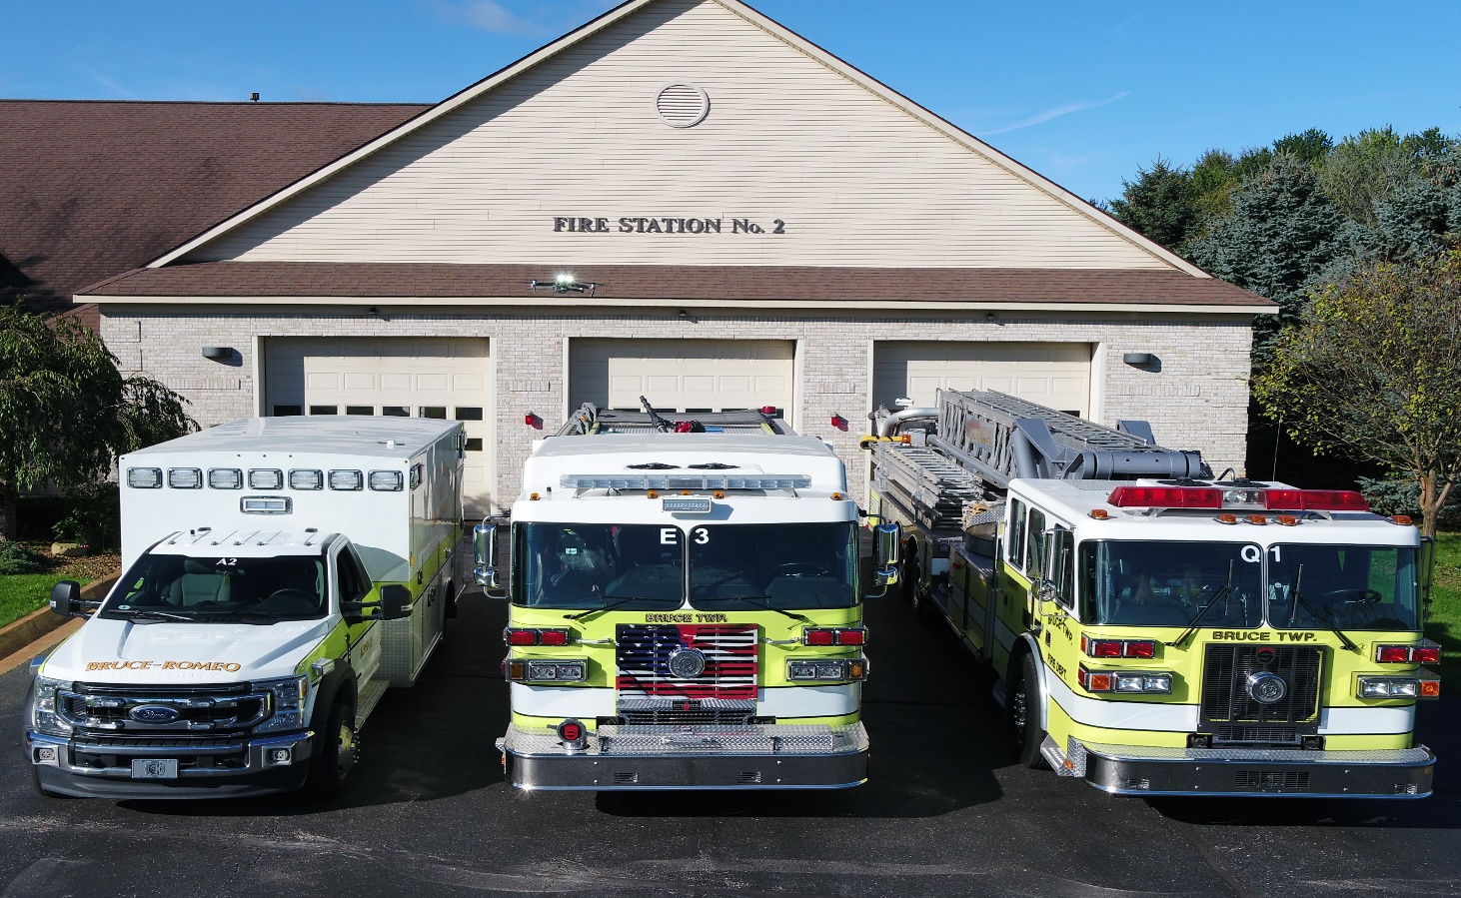
The Bruce Township Fire Department is establishing an open eligibility list in order to fill 1 Full-Time Firefighter/Paramedic position. Bruce Township Fire Department is a combination ALS Transporting Agency located in Northern Macomb County also providing ALS and Fire coverage to the Village of Romeo. Bruce Township Fire Department has three stations: Station 1 located at 223 E Gates, paid on call response station, Station 2 located at 75675 Van Dyke Ave. and Station 3 located at 229 E. Gates.
Opening Date: 12/26/2022 Closing Date: 01/24/2023
QUALIFICATIONS:
- Possession of a High School diploma or the equivalent
- 21 years of age
- Valid Michigan driver’s license
- Firefighter I & II certification
- Hazardous Materials First Responder Operations Certification
- State of Michigan Paramedic License
- CPAT or OPAT (OCC physical agility test) Certification. (or obtained prior to start date).

BENEFITS:
- Complete family health care coverage by BCBS
- Dental & Vision Insurance
- Employer contributed 457 deferred compensation plan @ 16% of base pay
- Annual food and clothing allowance
- Ten paid holidays
- Licensure continuing education credits obtained in house (including ACLS & PALS)
- Generous paid time off benefits
- Educational opportunities available for career and personal development

SALARY
$50,920- $83,334 (after five years)

Bruce Township Fire Department prides itself as being an exceptional Fire and EMS organization, continually training to provide outstanding services to the residents of Bruce Township and the Village of Romeo.
The physical demands and work environment described here are representative of those an employee encounters while performing the essential functions of the job.
Physical demands may range from station chores or duties, participating in daily firefighting training operations so that we are ready and prepared when called for services both physically and mentally. Also providing Advanced Life Support operations, or highly dangerous fire suppression and/or rescue situations. Therefore candidates must exercise strength, mobility, dexterity, stamina, and trust which is associated with firefighting and teamwork. We take extreme pride and dedication in our community, equipment, and stations with a 24/7 readiness to respond. If you are energetic, have the capabilities of performing in stressful environments, able to problem solve all while acting quickly, then this may be the perfect job for you!!

Documentation of all qualifications and resumes should be submitted to the Clerk’s Office located at:
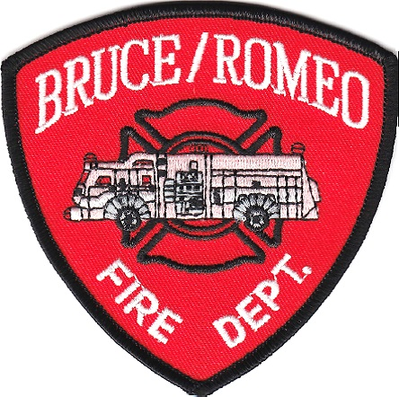
Bruce Township Hall
223 E. Gates
Romeo, Michigan 48065
Attn: David Witgen, Chief

Clerk Susan Kraft (586) 752-4585 ext. 116
EMAIL: skraft@brucetwp.org

Website:
www.brucetwp.org

Questions: call Chief Witgen
(586) 752-2520 ext. 143
EMAIL: dwitgen@brucetwp.org

Pre hire requirements: Background check and medical examination
All candidates will go in front of an oral board examination

