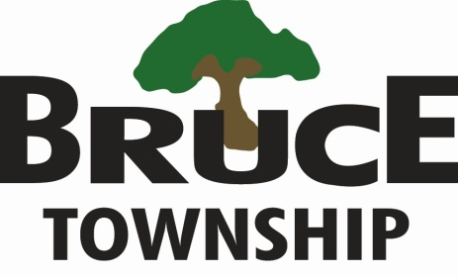
Proud Heritage-Planned Future
223 EAST GATES STREET
ROMEO, MICHIGAN 48065
586-752-4585 ~ Fax: 586-752-3870
www.brucetwp.org

To minimize the spread of COVID-19 and protect citizens from exposure, Bruce Township will be open with limited hours and staff (9:00 a.m. – 2:00 p.m.) M-F.

We are currently not accepting documents at the department windows. Please email documents or use the secure drop box located at the back entrance of the Township Hall. Leave a phone number and mailing address on whatever is dropped off.

Check our website www.brucetwp.org for updated information on closures and online services.

